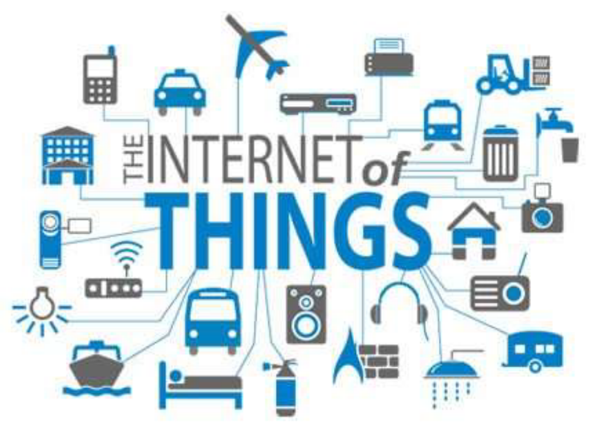

MUSKAN MAHAJAN
BTECH-CSE
DAV UNIVERSITY , JALANDHAR

Plan of Presentation:-
- What is Internet of Things?
- How IoTWorks?
- Current Status & Future Prospect of IoT
- Knowledge Management – From Data to Wisdom
- The Future of IoT
- The Potential of IoT
- Few Applications of IoT
- Challenges of IoT
- Criticisms & Controversies of IoT
- References

What is IoT?
The Internet of Things (IoT) is the network of physical
objects or "things" embedded with electronics, software,
sensors, and network connectivity, which enables these
objects to collect and exchange data.
IoT allows objects to be sensed and controlled
remotely across existing network infrastructure, creating
opportunities for more direct integration between the
physical world and computer-based systems, and resulting
in improved efficiency, accuracy and economic benefit

"Things," in the IoT sense, can refer to a wide variety
of devices such as heart monitoring implants, biochip
transponders on farm animals, electric clams in coastal
waters, automobiles with built-in sensors, DNA analysis
devices for environmental/food/pathogen monitoring or
field operation devices that assist fire-fighters in search
and rescue operations.
These devices collect useful data with the help of
various existing technologies and then autonomously flow
the data between other devices.

History of IoT:-
The concept of the Internet of Things first became
popular in 1999, through the Auto-ID Center at MIT and
related market-analysis publications. R
Radio-frequency identification (RFID) was seen as a
prerequisite for the IoT at that point. If all objects and
people in daily life were equipped with identifiers,
computers could manage and inventory them. Besides
using RFID, the tagging of things may be achieved through
such technologies as near field communication, barcodes,
QR codes, bluetooth, and digital watermarking.

Internet of Things:-
It is not the result of a single novel
technology; instead, several complementary technical
developments provide capabilities that taken together help
to bridge the gap between the virtual and physical world.
These capabilities include:
- Communication and cooperation
- Addressability
- Identification
- Sensing
- Actuation
- Embedded information processing
- Localization
- User interfaces

The Structure of IoT:-
The IoT can be viewed as a gigantic network
consisting of networks of devices and computers
connected through a series of intermediate technologies
where numerous technologies like RFIDs, wireless
connections may act as enablers of this connectivity.
- Tagging Things : Real-time item traceability and addressability
by RFIDs.
- Feeling Things : Sensors act as primary devices to collect data
from the environment.
- Shrinking Things : Miniaturization and Nanotechnology has provoked the ability of smaller things to interact and connect
within the “things” or “smart devices.”
- Thinking Things : Embedded intelligence in devices through
sensors has formed the network connection to the Internet. It
can make the “things” realizing the intelligent control.

IoT as a Network of Networks:-
These networks connected with added security, analytics, and
management capabilities. This will allow IoT to become even
more powerful in what it can help people achieve.
Knowledge Management:-
Turning Data into Wisdom-

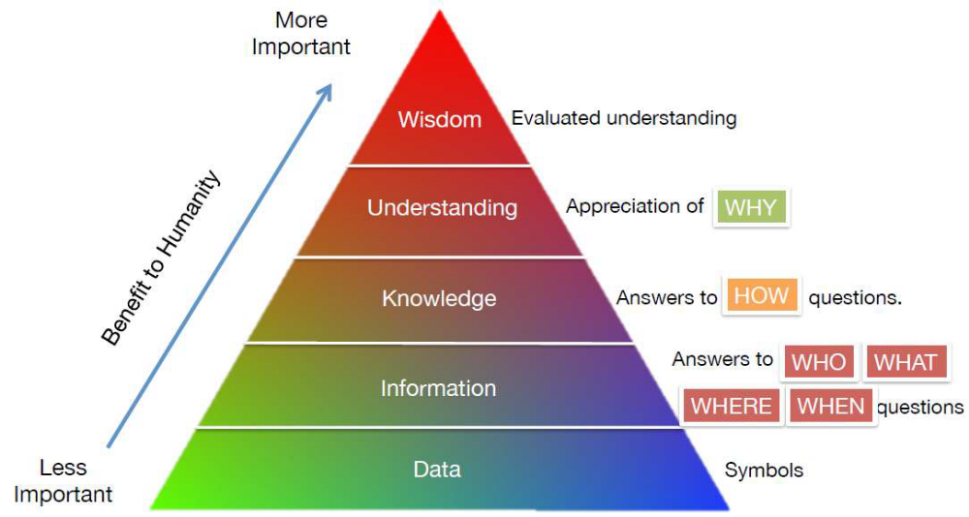

- The more data that is created, the better understandi wisdom people can obtain.

The Future of IOT:-
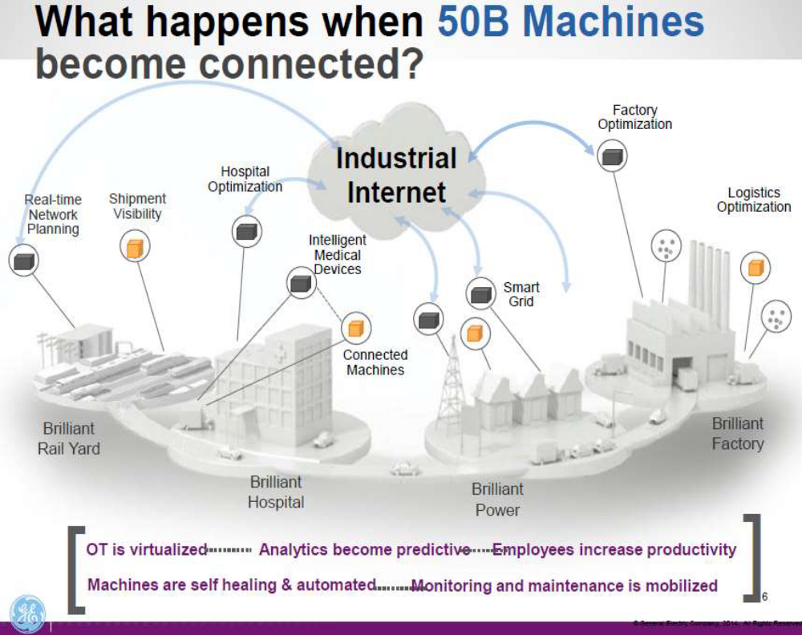

"The Sky's not the limit. It's only the beginning with IoT.”
The Potential of IoT:-

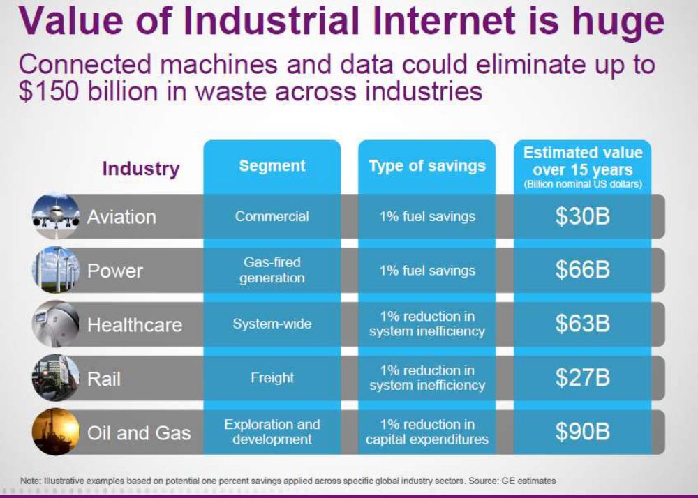

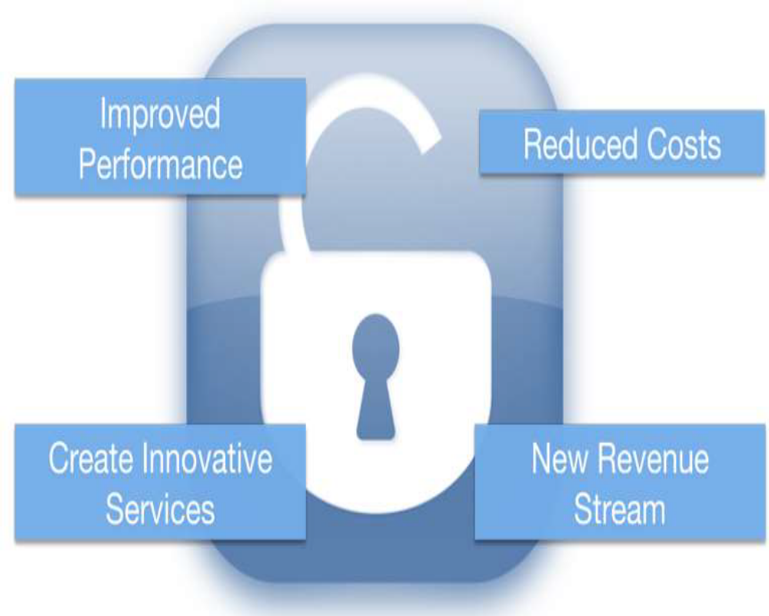

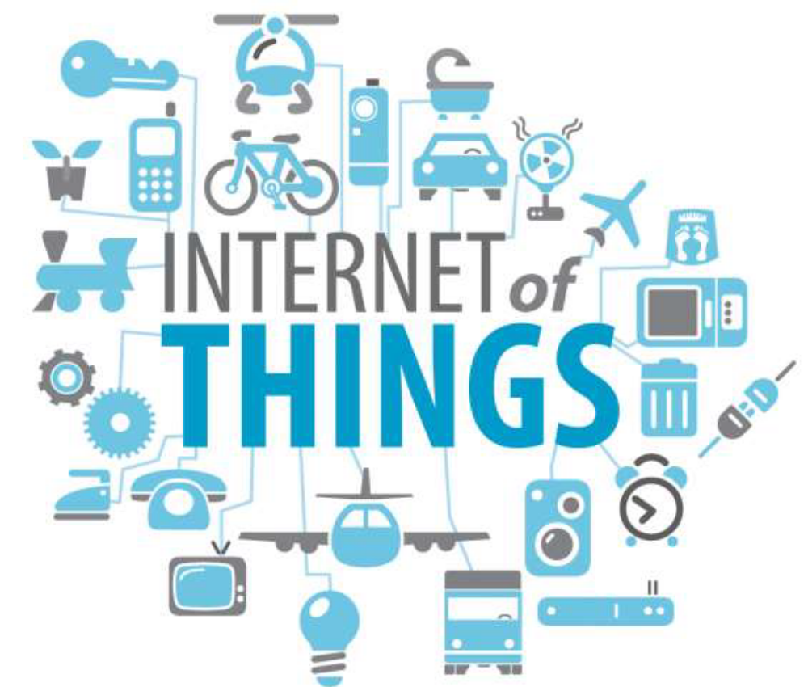

"The Ultimate Goal of IOT is to Automate Human Life."
Few Applications of IoT:-
- Building and Home automation
- Manufacturing
- Medical and Healthcare systems
- Media
- Monitoring
- Infrastructure management
- Energy management
- Transportation
- Better quality of life for elderly

You name it, and you will have it in IoT!

Sensors in even the holy cow!
In the world of IoT, even the cows will be connected
and monitored. Sensors are implanted in the ears of cattle.
This allows farmers to monitor cows’ health and track their
movements, ensuring a healthier, more plentiful supply of
milk and meat for people to consume. On average, each cow
generates about 200 MB of information per year.
Of course, we know nothing remains static, especially
when it comes to the Internet. Initiatives and advances,
such as Cisco‘s Planetary Skin, GE’s Industrial Internet,
HP‘s central nervous system for the earth (CeNSE), and
smart dust, have the potential to add millions—even
billions—of sensors to the Internet.
As cows, water pipes, people, and even shoes, trees,
and animals become connected to IoT, the world has the
potential to become a better place.
“With a trillion sensors embedded in the
environment—all connected by computing systems,
software, and services—it will be possible to hear the
heartbeat of the Earth, impacting human interaction with
the globe as profoundly as the Internet has revolutionized
communication.” - Peter Hartwell, Senior Researcher, HP
Labs.
“How much more IoT can do is only left to your
imagination”

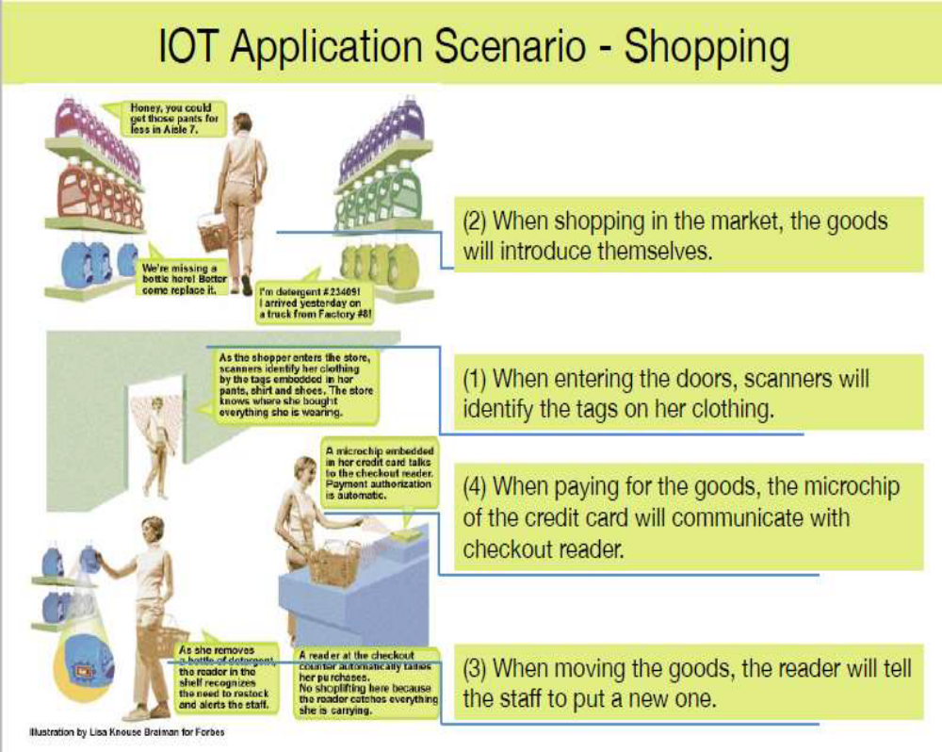

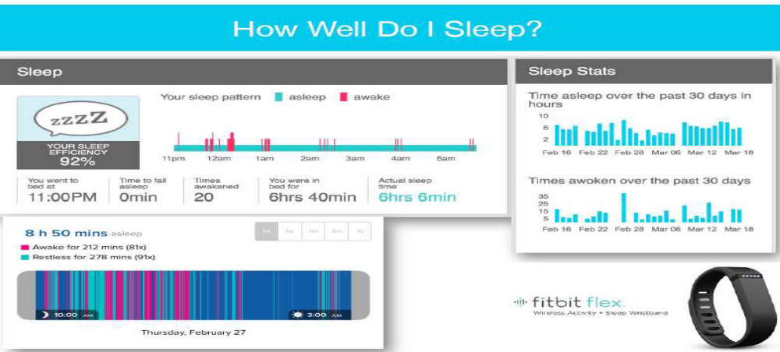

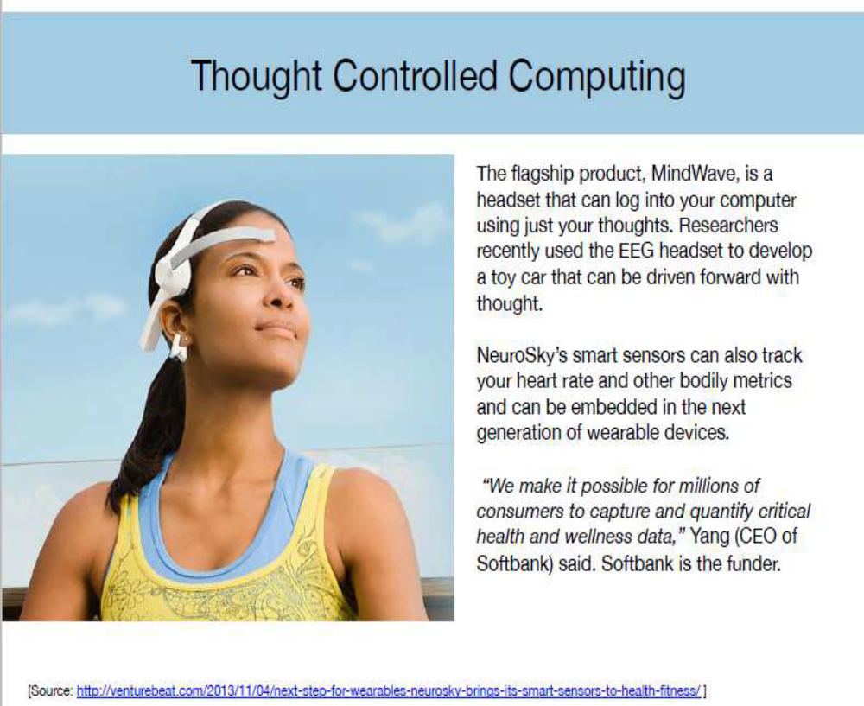

- TECHNOLOGICAL CHALLENGES OF IoT:-

- At present IoT is faced with many challenges, such as:
- Scalability
- Technological Standardization
- Inter operability
- Discovery
- Software complexity
- Data volumes and interpretation
- Power Supply
- Interaction and short range communication.

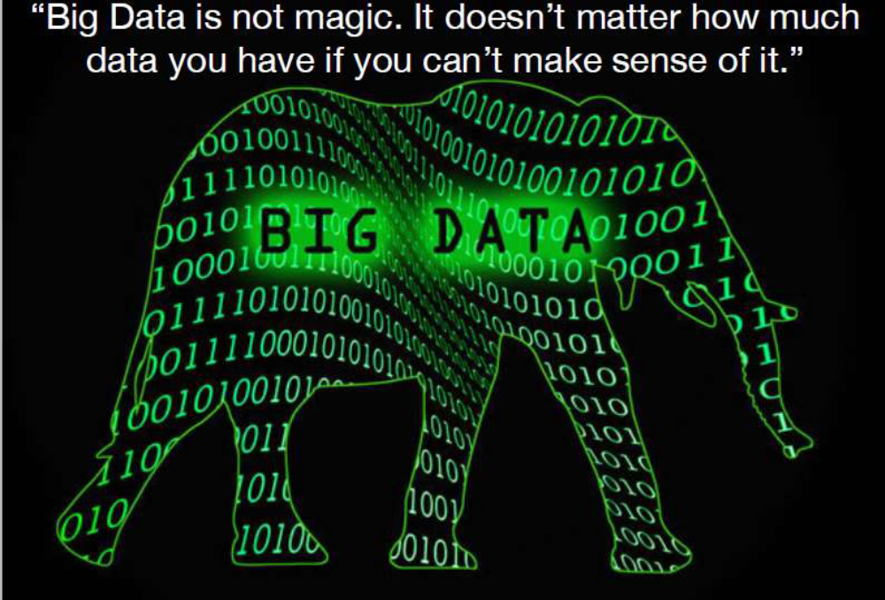

Criticisms and Controversies of IoT:-

Scholars and social observers and pessimists have
doubts about the promises of the ubiquitous
computing revolution, in the areas as:

- Autonomy and Control
- Social control
- Political manipulation
- Design
- Environmental impact
- Influences human moral decision making

References:-

1. www.google.com
2. https://en.wikipedia.org/wiki/Internet_of_Things
3. Cisco whitepaper, "The Internet of Things" - How the Next
Evolution of the Internet Is Changing Everything, by Dave Evans,
April 2011.
4. GE cloud expo 2014, "Industrial Internet as a Service", by Shyam
Varan Nath, Principal Architect.
5. Dr. Mazlan Abbas, MIMOS Berhad, Wisma IEM, Petaling Jaya.

THANK YOU

